**CHAPTER 3**

**SALES MONITORING SYSTEM FOR POSH AND FAB CONCEPT STORE WITH ONLINE VIEWING**

**3.1 Introduction**

This chapter showcase the development tools that involved in the proposed system. It defines the functions, concepts, flow of data involved, structure of its database and the design of its interface. Diagrams and Schema of the database is also showcased here to fully understand the relationship, flow and overall structure of the proposed system.

**3.2 System Design Specification**

This section will show the flow of all the diagrams that are made by the proponents for all the user of the proposed system. The desktop application is only accessible by the admin and the cashier with its exact role, while the website is accessible by the brand partners only. The admin can manage all the accounts of the cashiers and the brand partners and monitor the sales and the products. The cashier is capable of making transactions, and the brand partner are capable of viewing their own sales and products.

**3.3 Architectural Design**

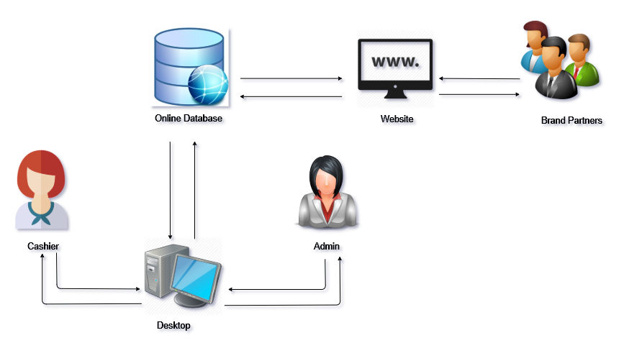

*General Architectural Design*

This section shows all the overall structure of the system including all the users (Admin, Cashier and Brand Partners). It explains the graphical representation of how the proposed system interacts to the database and the users. The admin and the cashier are users who can only access the system through desktop. Brand Partners on the other hand can directly access the system through website.

**3.3.1 Context Diagram**

*Context Diagram*

This section shows the context-level of the proposed system. It provides the relationship that the system has with other external entities and shows the capabilities of the system by its three users (Admin, Cashier and Brand Partners).

**3.3.2 Data Flow Diagram**

*Part 1. Data Flow Diagram for the System Admin*

The data flow diagram decomposes the context diagram into lower-level data flow diagrams. The figure above shows the supremacy of the administrator in the whole system structure over any other users.

*Part 2. Data Flow Diagram for the System Admin*

Part 2 is a continuation of the system admin’s access to the system. In this figure, the admin is allowed to manage the addition of item, viewing and archiving the items.

*Part 3. Data Flow Diagram for the System Admin*

The admin’s access is continued in Part 3 Data Flow Diagram for the system admin. Shown here is the process by which the admin is able to generate reports.

*Data Flow Diagram for the Cashier*

It shows here that the only function of the cashier aside from logging in is Manage Transactions.

*Data Flow Diagram for the Brand Partner*

Figure above shows the designated access of the Brand Partner. This user can only access the system by logging in website. They can able to view their item stocks at website and able to generate their sales.

**3.3.3 Entity Relationship Diagram**

*Entity Relationship Diagram*

Figure above shows the proposed system’s database structure or schema. Here, the relations or commonly referred to as tables are specified as well as the attributes or columns they contain. This diagram shows the relationship between each table through their respective primary and/or foreign keys that serves as identifiers for a particular record.

**3.3.4 Hierarchical Input Process Output**

*Hierarchical Input Process Output Diagram for the System Admin*

*Hierarchical Input Output Process Diagram for the Cashier*

*Hierarchical Input Output Diagram for Brand Partner*

**3.4 Development Tools**

In the course of system development, the proponents used the following hardware and software applications:

**3.4.1 Software**

* **Microsoft Visual Studio C#.net 2015**

To achieve the desired features of what the client asked, the proponents used this programming language in making the desktop application that is to be used by the administrator and for the cashier.

* **HTML, CSS and JavaScript**

The proponents used the programming languages to have a structure for the website that is to be used by the brand partners.

* **XAMPP**

A development tool used by the proponents to test their work locally without the use of internet.

* **Microsoft Word**

The proponents used this application for the documentation of the proposed system.

**3.2.1.2 Hardware**

* **Input Devices** 
  + **Keyboard**
  + **Mouse**
* **Output Devices**
  + **Monitor**
  + **Mobile Phones**

**3.5 Summary**

The proponents used diagrams to provide a visual imagery of how the system works. This chapter made use of these diagrams to help the proponents in achieving the necessary functions as the actual application is created in a sequential and organized manner possible. These diagrams became backbone of the developed software and the guide to which the system is created.